COM521 Week 2 Session Hijacking Activities

Cookies and session ID’s Investigation with Developer tools
To inspect the content of cookies, including session IDs, you can use the developer tools in your web browser. Here’s how you can do it in Microsoft Edge:
- Open Developer Tools:
  - Press F12 or right-click on the page and select Inspect.
- Navigate to the Application Tab:
  - In the Developer Tools pane, go to the Application tab.
- Find Cookies:
  - In the left-hand sidebar, under Storage, click on Cookies.
  - You will see a list of domains. Select the domain you are interested in.
- Inspect Cookie Content:
  - You will see a table with all the cookies set by that domain. The table includes columns for Name, Value, Domain, Path, Expires/Max-Age, Size, HTTP, Secure, and SameSite.
  - Look for the cookie that contains the session ID. It is usually named something like sessionid, sid, or similar.
- View and Analyze:
  - Click on the cookie to view its details. The Value column will show the session ID and other data stored in the cookie.
Here’s a quick example of what you might see:
Name | Value | Domain | Path | Expires/Max-Age | Size | HTTP | Secure | SameSite
sessionid | abc123xyz789 | example.com | / | Session | 45 | Yes | Yes | Lax
If you need to analyze or manipulate these cookies for development or debugging purposes, this method will give you a clear view of their content. Just remember to handle session IDs and other sensitive information with care to maintain security.

Task: Managing Cookies Using Developer Tools
Objective: Learn how to use Developer Tools in Edge or Chrome to manage cookies.
Steps:
- Open Developer Tools:
  - In Edge or Chrome, press F12 or Ctrl+Shift+I (Windows/Linux) or Cmd+Opt+I (Mac) to open Developer Tools.
- Navigate to the Solent Portal:
  - Open your browser and go to www.solent.ac.uk/portal.
- Find the Cookie Control Cookie:
  - In Developer Tools, go to the Application tab.
  - Under the Storage section, click on Cookies and select the domain www.solent.ac.uk.
  - Look for a cookie named Cookie Control or similar.
- Delete the Cookie:
  - Right-click on the Cookie Control cookie and select Delete.
- Refresh the Page:
  - Refresh the Solent portal page to see the changes.
Outcome: You should see the cookie consent prompt again, as the cookie storing your previous consent has been deleted.
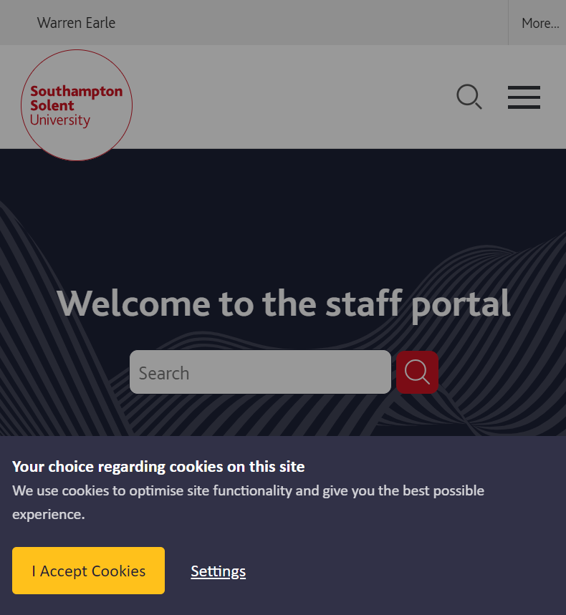
koa.sess is a key used by the Koa framework’s session middleware to store session data in cookies. Koa is a popular web framework for Node.js, and its session middleware allows you to manage user sessions easily. The key koa.sess was introduced to ensure that the cookie name complies with HTTP specifications¹².
When you use Koa’s session middleware, it defaults to using cookies to store session data. The koa.sess cookie contains the session information, which is sent to the server with each request. This helps maintain user state across different requests.
The session is stored in a cookie by default, but it has some disadvantages:
- Session is stored on client side unencrypted
- Browser cookies have length limits

- Inspect and Record the koa.sess Value:
  - After logging in to www.solent.ac.uk/portal , open your browser’s developer tools (usually by pressing F12 or Ctrl+Shift+I).
  - Navigate to the “Application” tab (in Chrome) or “Storage” tab (in Firefox).
  - Under “Cookies,” find the koa.sess cookie and record its value.
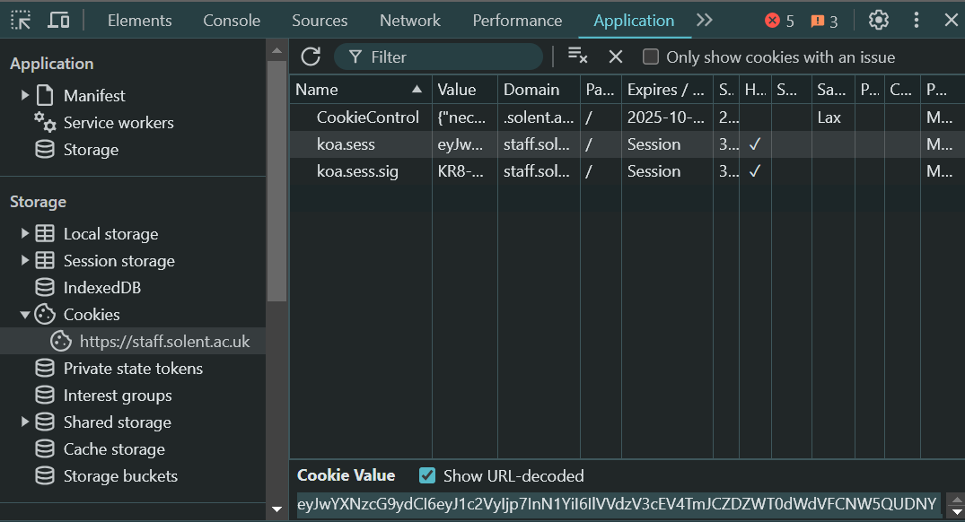
- Generate MD5 Hashes:
  - Go to MD5hashgenerator.com.
  - Enter the recorded koa.sess value and generate the MD5 hash.
  - Log out, restart the browser, log in again, and repeat the process to get the new koa.sess value.
  - Generate the MD5 hash for the new koa.sess value.
- Compare the Hashes:
  - Note down both MD5 hashes.
  - Compare the hashes
  - What does it mean if they are different ?
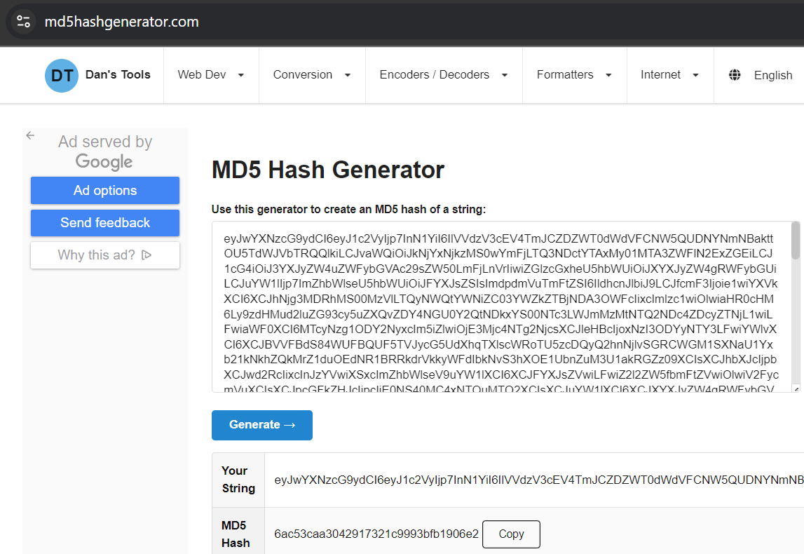
- Compare the characters in the session ids
  - Go to Diffchecker.com.
  - Enter the two koa.sess cookies recorded in the respective text boxes.
  - Select Character on the right.
  - Click “Find Difference” to highlight any character differences between the two session IDs.

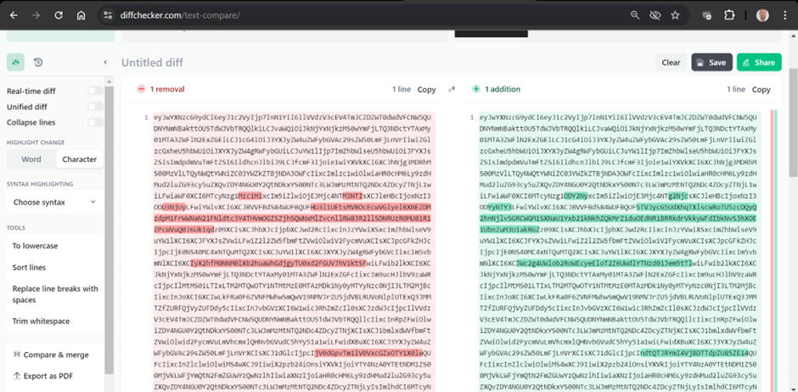
By following these steps, you can inspect and compare the session IDs to ensure they are being properly reset. If you notice any discrepancies, it might indicate an issue with how sessions are being managed in your application.
The similarity in koa.sess values could be due to several factors related to how sessions are managed and configured in the Koa.js application. Here are a few possibilities:
- Default Configuration: If you’re using the default configuration for session management, the session values might appear similar because they follow a standard format or structure. This doesn’t necessarily mean they are predictable or insecure.
- Session Store: If you’re using a session store (like Redis or a database), the way sessions are serialized and deserialized might result in similar-looking values. The underlying data might still be unique and secure.
- Cookie Settings: The koa.sess cookie might have similar values if the session data stored in the cookie is minimal or if the cookie settings (like expiration time) are consistent across sessions.
- Session Middleware: The middleware you’re using for session management might influence the format of the session values. For example, koa-session has specific ways of handling and encoding session data¹.
To ensure your sessions are secure, consider reviewing your session management configuration and implementing best practices such as using strong, random session IDs and securing your cookies.

